**WHAT IS GNU EMACS?**

An extensible customizable, free/libre text editor and more.

At its core is an interpreter for Emacs Lisp, a dialect of the Lisp programming language with extensions .To support text editing.

HOW DOES A EMAC EDITOR LOOK LIKE?

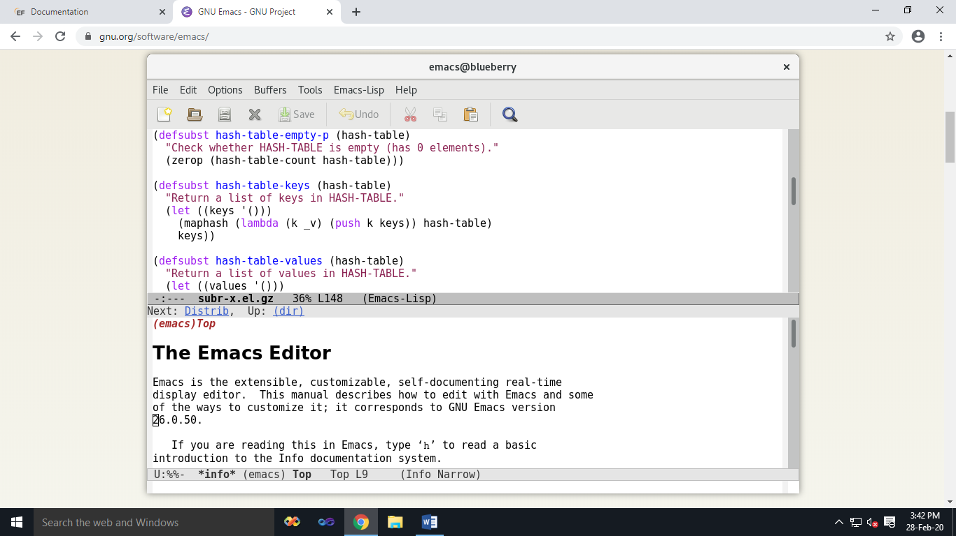

**GNU Emacs**

[](https://www.gnu.org/software/emacs/emacs.html)

An extensible, customizable, [free/libre](https://www.gnu.org/philosophy/free-sw.html) text editor — and more.

At its core is an interpreter for Emacs Lisp, a dialect of the Lisp programming language with extensions to support text editing.

THE FEATURES OF GNU EMACS INCLUDE:

* Content-aware editing modes, including syntax coloring, for many file types.
* Complete built-in documentation, including a tutorial for new users.
* Full [Unicode](http://unicode.org/) support for nearly all human scripts.
* Highly customizable, using Emacs Lisp code or a graphical interface.
* An entire ecosystem of functionality beyond text editing, including a [project planner](https://www.gnu.org/software/emacs/manual/org.html), [mail and news reader](https://www.gnu.org/software/emacs/manual/gnus.html), [debugger interface](http://www.gnu.org/software/emacs/manual/html_node/emacs/Debuggers.html), [calendar](https://www.gnu.org/software/emacs/manual/html_node/emacs/Calendar_002fDiary.html), and [more](https://www.gnu.org/software/emacs/further-information.html).
* A packaging system for [downloading and installing](http://elpa.gnu.org/) extensions.

## RELEASES:

## Emacs 26.3 - Latest release

### Released Aug 28, 2019

[Emacs 26.3](https://www.gnu.org/software/emacs/news/NEWS.26.3) is a maintenance release.

* New GPG key for GNU ELPA package signature checking.

## Emacs 26.2

### Released Apr 12, 2019

[Emacs 26.2](https://www.gnu.org/software/emacs/news/NEWS.26.2) has a wide variety of new features, including:

* Emacs modules can now be built outside of the Emacs tree source.
* Emacs is now compliant with the latest version 11.0 of the Unicode Standard.
* In Dired, the 'Z' command on a directory name compresses all of its files.

## Emacs 26.1

### Released May 28, 2018

[Emacs 26.1](https://www.gnu.org/software/emacs/news/NEWS.26.1) has a wide variety of new features, including:

* Limited form of concurrency with Lisp threads
* Support for optional display of line numbers in the buffer
* Emacs now uses double buffering to reduce flicker on the X Window System
* Flymake has been completely redesigned
* TRAMP has a new connection method for Google Drive
* New single-line horizontal scrolling mode
* A systemd user unit file is provided
* Support for 24-bit colors on capable text terminals

## Emacs 25.3

### Released September 11, 2017

[Emacs 25.3](https://www.gnu.org/software/emacs/news/NEWS.25.3) fixes a significant security hole.

## Emacs 25.2

### Released April 21, 2017

Emacs 25.2 is mostly a bug-fix release.  
For more information, read the [News](https://www.gnu.org/software/emacs/news/NEWS.25.2) file.

## Emacs 25.1

### Released September 17, 2016

See also [dates of older releases](https://www.gnu.org/software/emacs/history.html).

Emacs 25.1 has a wide variety of new features, including:

* Emacs can now load shared/dynamic libraries (modules). A dynamic Emacs module is a shared library that provides additional functionality for use in Emacs Lisp programs, just like a package written in Emacs Lisp would.
* Experimental support for Cairo drawing.
* Enhanced network security (TLS/SSL certificate validity and the like) via the new Network Security Manager (NSM).
* New minor mode 'electric-quote-mode' for using curved quotes as you type.
* Character folding support in isearch.el.
* New and improved facilities for inserting Unicode characters: C-x 8 now has shorthands for several chars, such as U+2010 (HYPHEN), U+2011 (NON-BREAKING HYPHEN), and U+2012 (FIGURE DASH).

## Documentation

Two Emacs manuals, the GNU Emacs manual and An Introduction to Programming in Emacs Lisp, can be purchased in printed form from the [FSF store](https://shop.fsf.org/).

These manuals, along with the Emacs Lisp Reference Manual and several other manuals documenting major modes and other optional features, can also be read online. They are also distributed with Emacs in [Info](https://www.gnu.org/software/texinfo/) format; type C-h i in Emacs to view them.

## Reporting bugs

To report bugs, or to contribute fixes and improvements, use the built-in Emacs bug reporter (M-x report-emacs-bug) or send email to [bug-gnu-emacs@gnu.org](http://mail.gnu.org/mailman/listinfo/bug-gnu-emacs). You can browse our bug database at [debbugs.gnu.org](http://debbugs.gnu.org/). For more information on contributing, see the [CONTRIBUTE](https://www.gnu.org/software/emacs/CONTRIBUTE) file (also distributed with Emacs).

For all other queries, consult the [list of Emacs-related mailing lists on savannah.gnu.org](http://savannah.gnu.org/mail/?group_id=40) and the [complete list of GNU mailing lists on lists.gnu.org](http://lists.gnu.org/mailman/listinfo/). See [Get Help with GNU Software](https://www.gnu.org/help/gethelp.html) for help with GNU software in general.